|  |  |  |
| --- | --- | --- |
| f |  |  |
| **Benha University** |  | **Faculty of Computers & Artificial Intelligence** |

**E-Commerce**

A summer training project submitted in partial fulfillment of the requirements for the degree of Bachelor of Computers & Artificial Intelligence.

**2nd Level Students Summer Training**

*Project Team*

1. Mahmoud Kamal Moahmed
2. Mohamed Fathy Mohamed
3. Norhan Mostafa Fareed
4. Mahmoud Kamal Mohamed
5. Ahmed Mohamed Hafez
6. Mahmoud Khaled Mahmoud
7. Mahmoud Rabeea Mahmoud
8. Farah Mohamed Kamel

August 2021

We hereby certify that this project, submitted by the project teamwork, conforms to acceptable standards and is fully adequate in scope and quality to fulfill the seminar requirements for the degree of Bachelor of Computers and Informatics.

**Discussion Committee:**

____________________________________ ________________

Date

____________________________________ ________________

Date

____________________________________ ________________

Date

Contents

**Abstract** 4

**Introduction** 1

**Program Interface** 3

**Program Execution** 5

First page: (login page) 5

Second page: (register page) 6

Third page: (home page) 7

Forth page: (shop page) 8

Fifth page: (product details page) 11

Sixth page: (liked products page) 12

Seventh page: (shopping cart page) 12

Eighth page: (checkout page) 13

Dashboard: (admin main overview page) 14

**Program Structure** 15

**Case study** 22

**Improvements and Extensions** 25

**Conclusion** 26

# **Abstract**

At first, this project is about an online store where you can: register a new email account or connect with an existing account, view and explore the most recent collection and categories of clothing, and filter them by: Category, Brand, Price, color, and size. That way, you can be confident you're getting the best deal possible. After you've found the item you want, you can save it to your favorites and come back to it later. You'll also get a brief but informative description of the item. You'll also find the pricing of the item, as well as the available colors and sizes, and you'll be able to add it to your basket and continue browsing, then check out your purchases, or add it to your favorites to return later. If you've added something to your favorites list, you may go back and look at it. You'll see a brief description of each item. After you've added products to your cart, you can check them out to see information about your orders, such as the product name, price, the number of pieces you purchased, and the total charge after shipping and taxes. You can remove or add goods there, and after you're satisfied with your purchase cart, you can check out and be redirected to the payment section. So that you can complete your order and make your payments.

# **Introduction**

The site is working to create an effective and user-friendly solution to make online buying more convenient. Because it allows you to create an E-Mail, you can assure that your selections and orders are secure and private. You may choose and explore things from a variety of categories such as Men, Women, and Kids, thanks to a sleek interface and user-friendly layout. Where you may choose from a variety of things, with the unique ones featured under the Deal of the Week section, and we'll go through all of the sections in detail later. In the bottom part, you'll find an overview of the site's contributors and supporters, as well as information on how to contact the developer. or if you want to keep up with the latest shop and special deals by receiving daily emails. A list to navigate around the many sections of the site can also be found in the upper section of the dashboard page. When you click the "shop" category, you will be taken to a new page where you may explore and select from a variety of products, as well as filtering the desired product by category, brand, price, color, and size. Alternatively, you can get more information about any product or add it to your favorites list. In addition, the identical navbars were utilized across all pages and were fixed. After selecting a product to read its full information, you will be transported to a new page where you will find multiple photographs of the product, as well as the price and more thorough specifications or description, as well as the available colors and sizes and the remaining stock number. When you add things to your favorites, you may see and delete them, as well as modify the list and, of course, add them to your shopping cart.

When you add things to your cart, you'll see a list of them along with their total price, and you'll be able to update the cart or proceed to the checkout section after you're satisfied with your pick.

# **Program Interface**

**

# **Program Execution**



This header contains the home page, a shop page, and a collection menu that contains three options: 1- Men's products 2- Women's products 3- Children's products The header also contains a shopping cart page and an account menu that contains a new account creation page and a login page.

## First page: (login page)

As you can see, the upper navbar is in the header, allowing you to easily navigate across all pages, including the home-dashboard, shop, collection, cart, favorite products-favorite, and login or register. You can login with your existing account, if you have one, by entering your e-mail and password into the two text boxes on this page, and then clicking login to be sent to the shop page. If you don't already have an account, select "create an account" to set up a new one. Some of the sponsors and contributors are included in the bottom bar, and the bottom-most bar also has information on how to contact us, how to access your account, and how to receive daily notifications about the latest shop and special discounts.

## Second page: (register page)

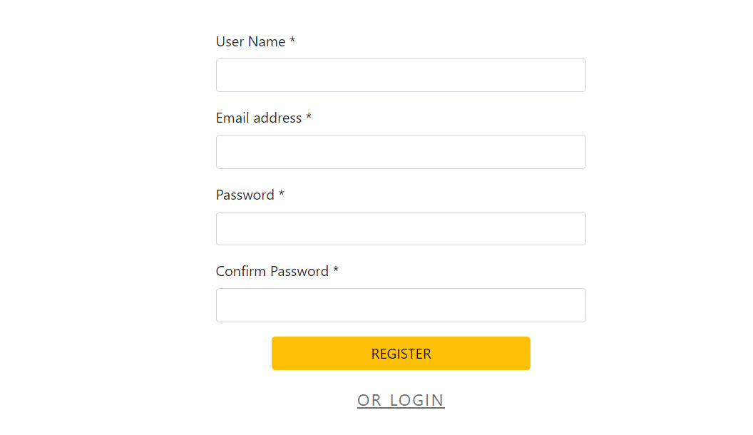

This page only appears if you are visiting the site for the first time and have not yet created an exciting account. You must first enter your e-mail address and password, then confirm your password, and finally press register to complete the registration process.

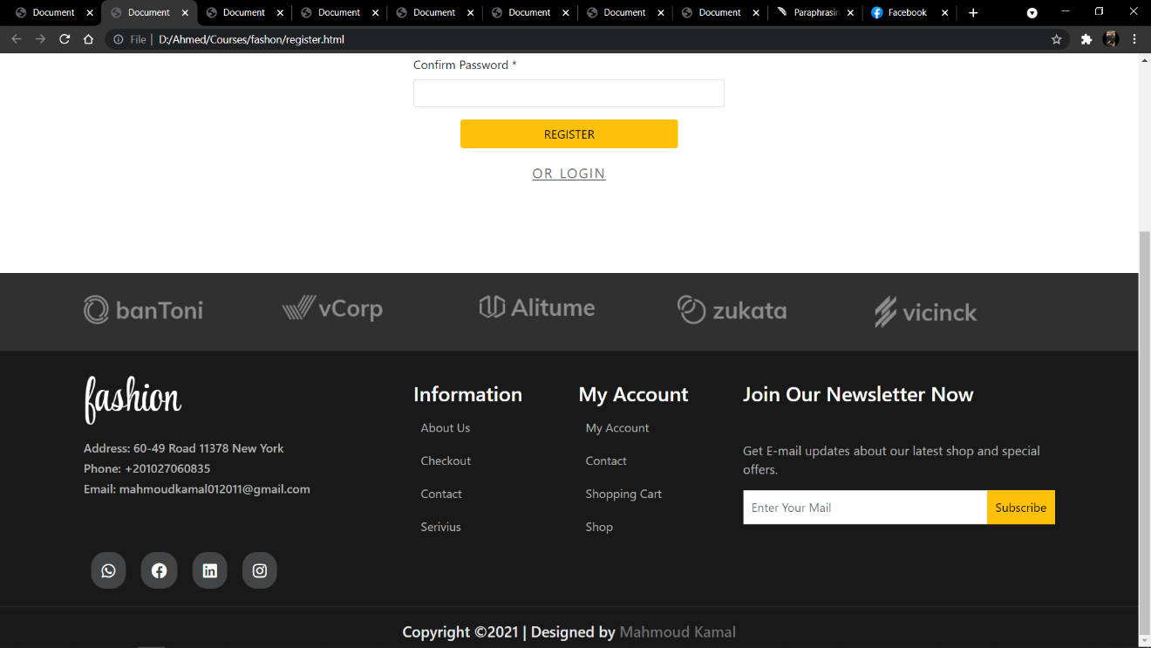

Contact information, as well as links to your account, cart, and shop, as well as whether you want to get daily emails to stay up with the latest store and special discounts, can be found at the bottom of all pages.

## Third page: (home page)

This page contains various sections in and of itself, such as categories, deal of the week, men's and women's clothing, a background carousel with some of the new items and some of the new arrival collections, and a backdrop carousel with some of the new arrival collections. You can save them to your favorites or add them to your cart to check them out later.

## Forth page: (shop page)

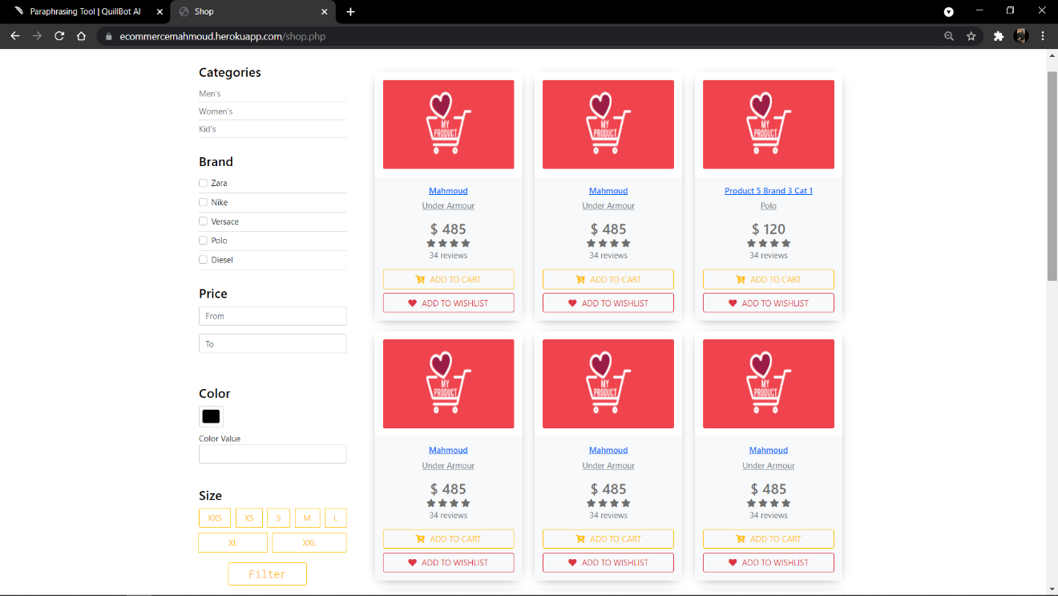

This page contains of the products you can purchase like: Men’s clothes, Women’s clothes, Kid’s clothes. Hare you can filter the items according to: Category (men, women and kids), Brand (we have bunch of different brands), price (where you can pick a range of prices according to your desirable price or budget and you can also filter by size (small, medium, large and more…) also you'll be able to add any item to your cart or to your favorite products as you like. The shop page: On this page, you can choose the categories that you want,

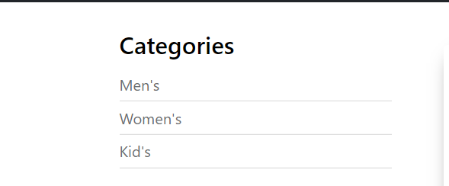

and you can also choose the brand that you want,

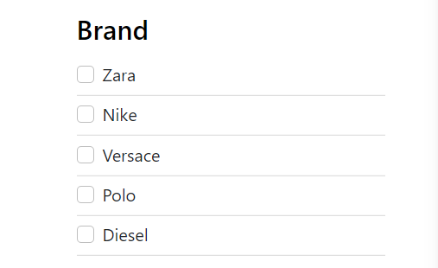

Also, you can set the price you want, and it will show you the products in the range you specify.

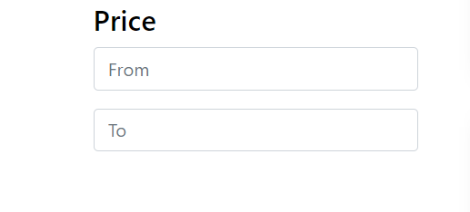

You can also select the appropriate size

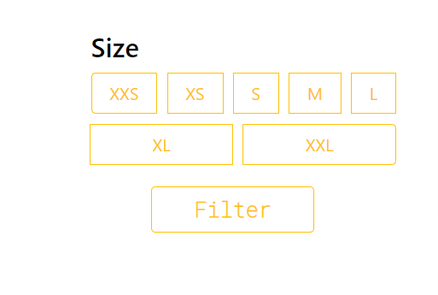

You can also buy the product you want and you can add it in the Likes section.

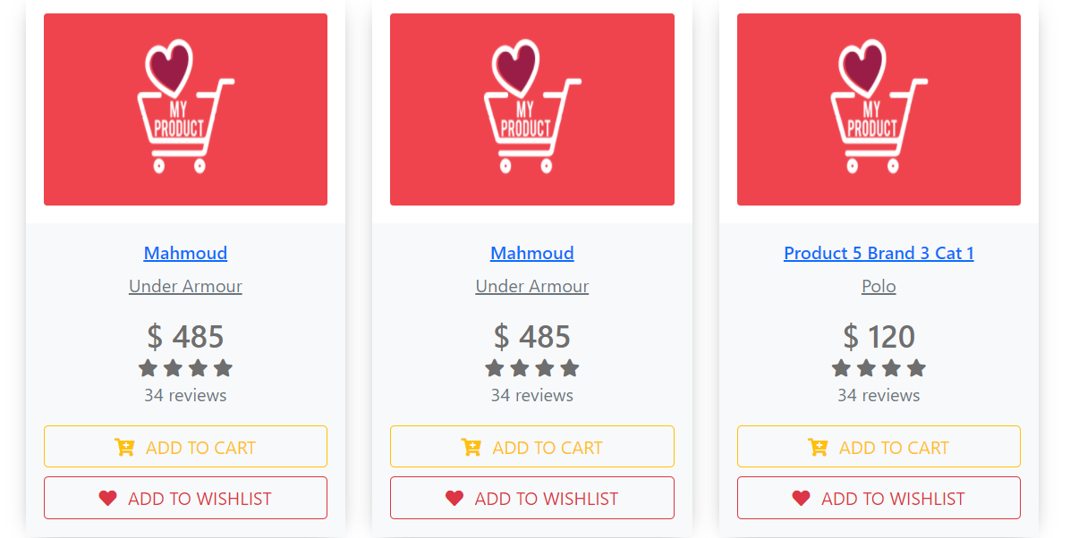

## Fifth page: (product details page)

You'll be able to see more extensive information about any product you've chosen in this section. Starting with the -obviously- product name and price, you'll be able to check how many items are in stock and choose from a number of available colors and sizes, as well as view how many items are in stock. Then there's the total price, which includes the product price as well as any applicable taxes and delivery costs. There's no need to specify that you'll have some images of the merchandise from various perspectives to ensure that the consumer receives exactly the product he requested. Following that, under the heading "overview," there will be more thorough information on the product, including technical data such as the fabric used, the manufacturing country, and so on...

## Sixth page: (liked products page)

This page displays the products that the consumer liked and placed to his favorites, allowing him to access them at any time and add them to his cart for purchase. Each product will have its own name and price, as well as the quantity of stock he desires, and finally the total price of each product, as well as whether he will add it to the cart or remove it from the list.

## Seventh page: (shopping cart page)

Here you can see the products that you’re acquiring and wants to purchase. After choosing an item then adding to the cart was selected it’ll appear in this particular frame much like the liked products frame but you'll get two more additional buttons and one more addition information: you'll get the ability to update your cart by either adding items to it, increasing the quantity of items. And there's a checkout button where you can indicate that you're happy with your order and are ready to move on to the payment and checkout page. An additional piece of information is that you will receive the entire cost of your transaction in order to keep track of what you will be paying for.

## Eighth page: (checkout page)

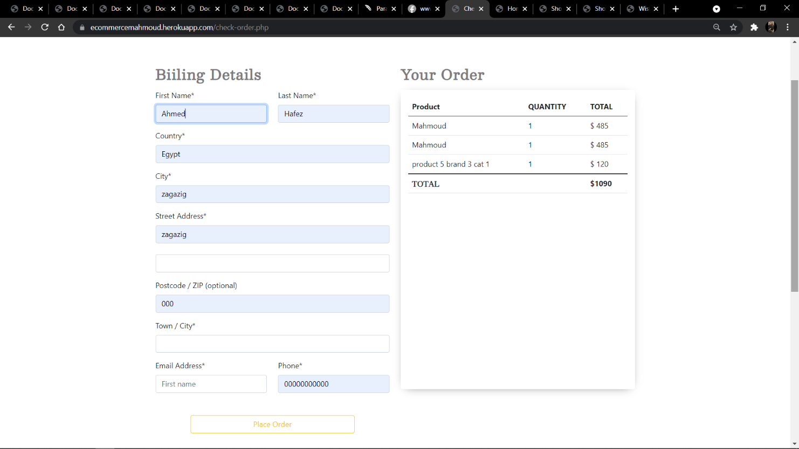irst

You'll be able to enter your billing information here (first and last name, country and city address, postal and zip code, as well as your contact information like email address and phone number) so that when you place your order, a receipt will appear on the right side of the page with all of the necessary information.

## Dashboard: (admin main overview page)

This portion of the dashboard was built to allow the administrator to control and customize all site-related properties. He'll be able to see a summary of the site's parts, such as the number of brands you have and how many orders customers have placed, as well as the number of categories, goods, users, and options you have. As you can see, there is a side bar from which you may browse to additional panels and view comprehensive information about each one.

# **Program Structure**

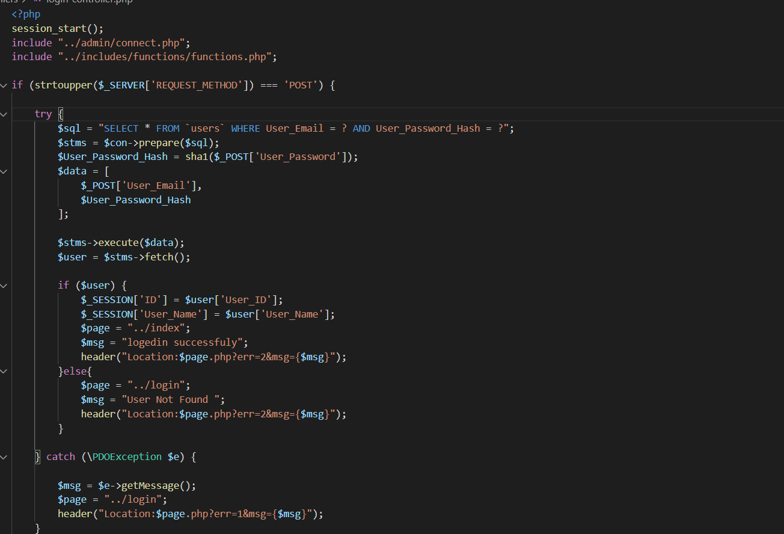 When a user enters an e-mail address and a password, the login control page checks to see if the user is already in the database..

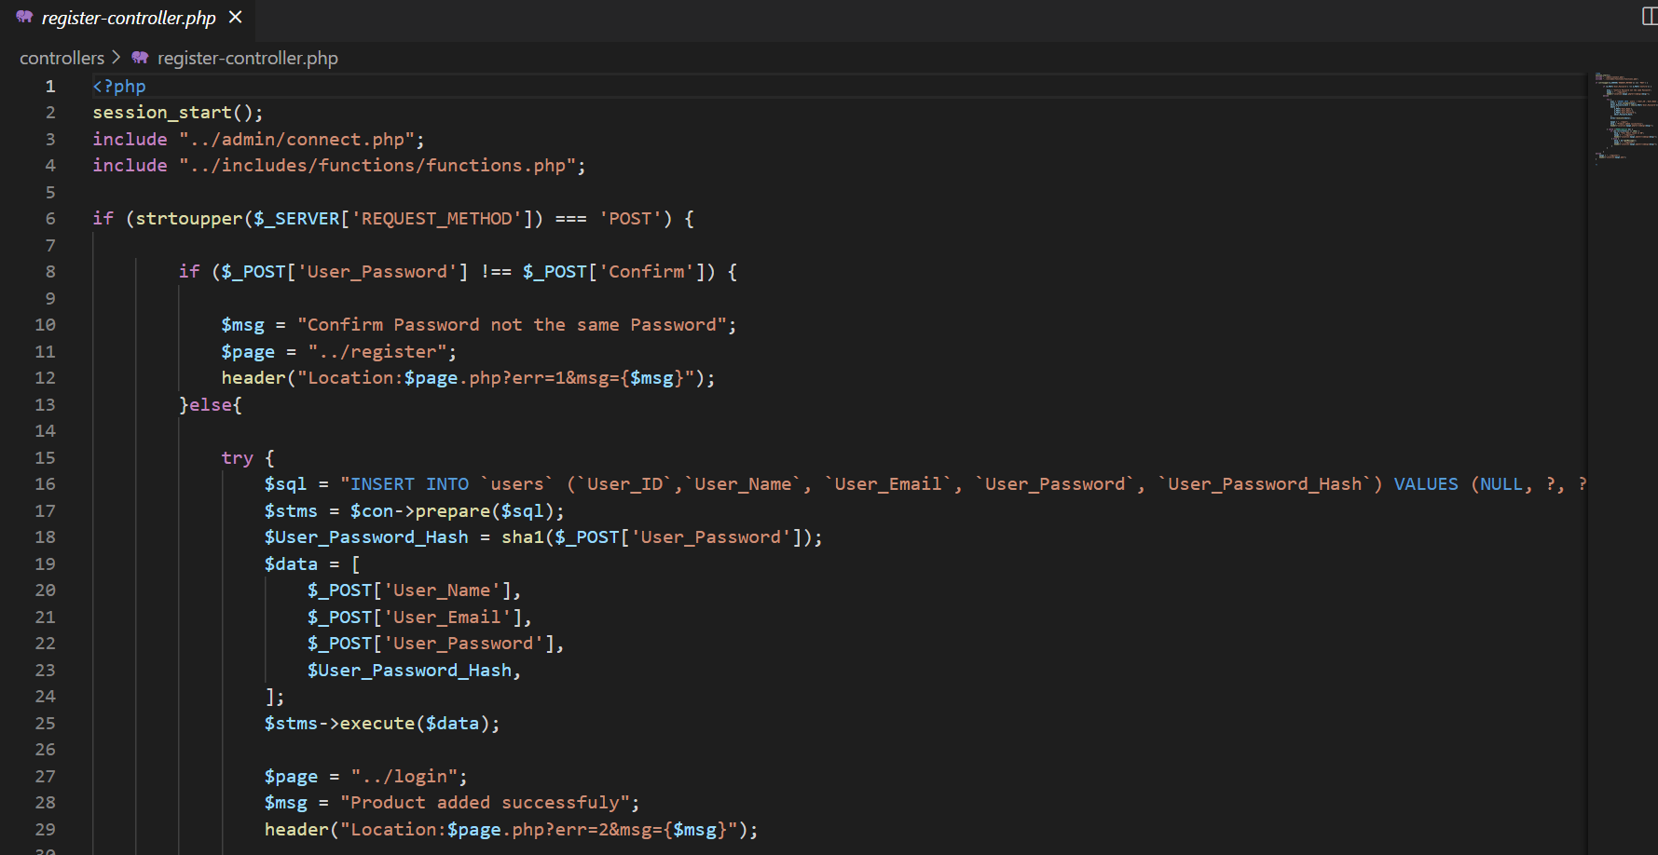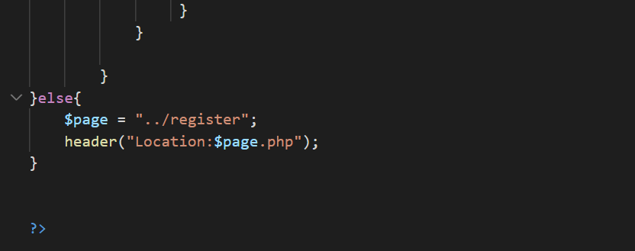It records the data that the user enters and confirms whether the data is correct or not, and checks to see if this email has been registered before or not; if it has, it displays an error message; if the data is correct, he records it in the database and converts it to the home page; if the data is incorrect, he displays an error message; and if the data is correct, he records it in the database and converts it to the home page..

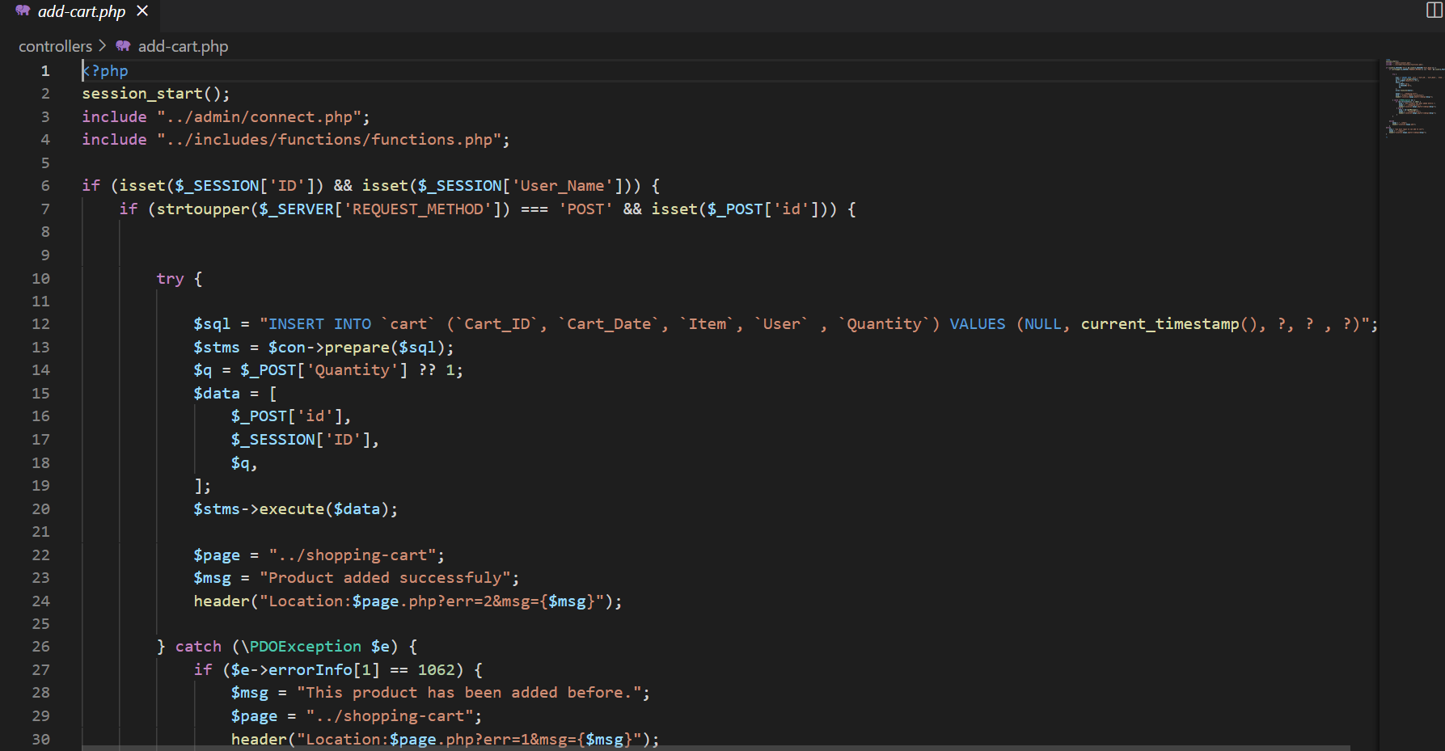 This page maintains information about the user when the user adds a product to the cart, and when the purchase is completed, this item is removed from the shopping cart..

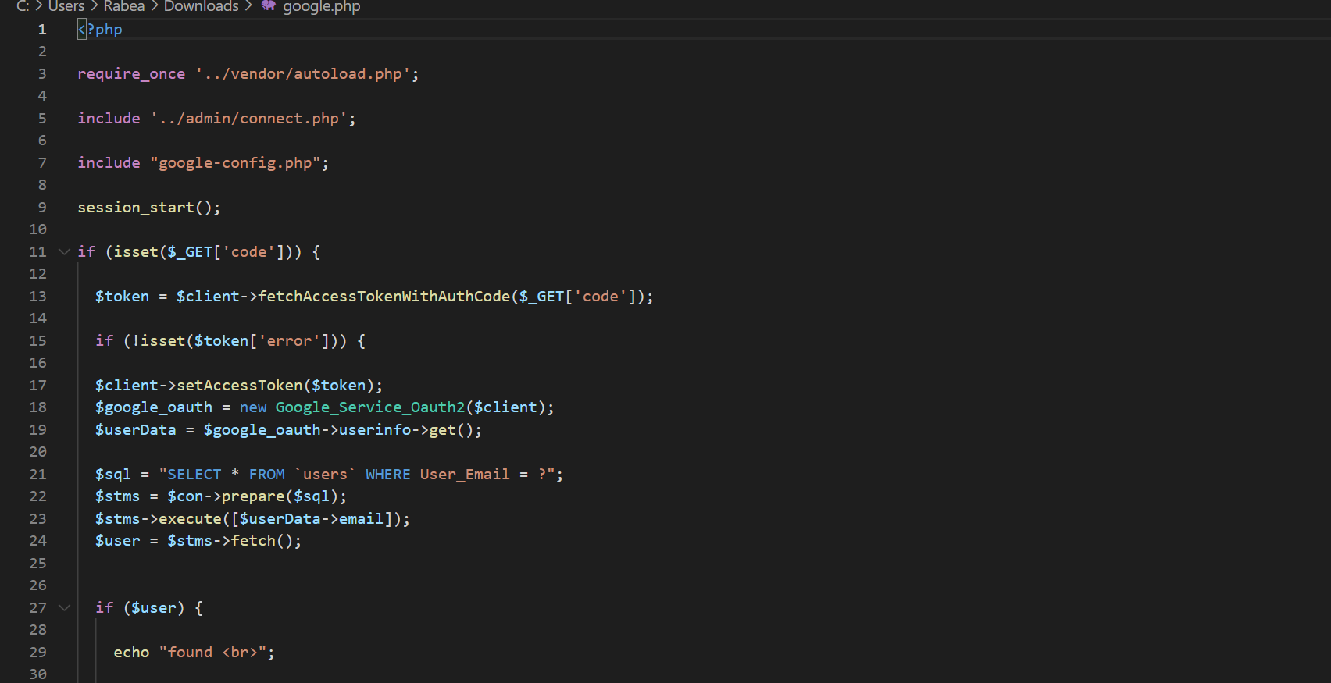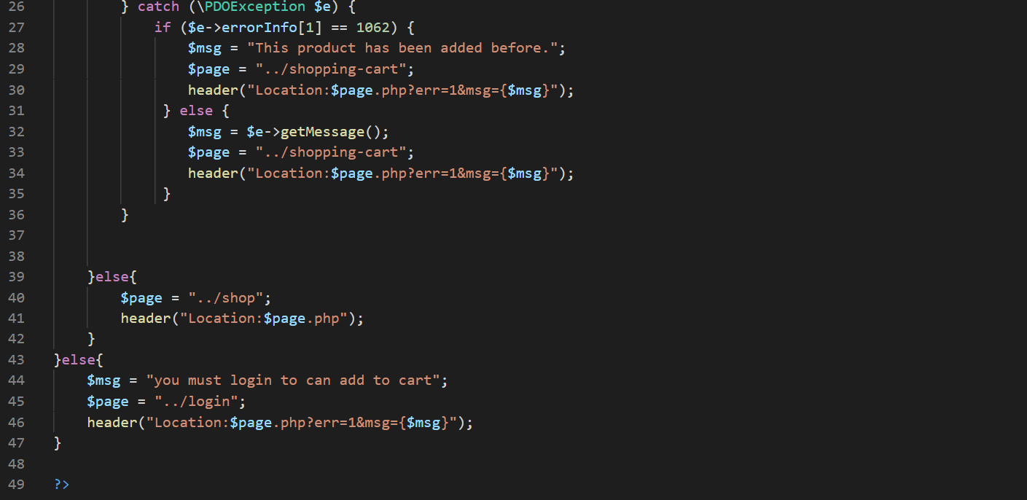This section provides Google login api settings, which may be found on this page. Fetch the token, then authenticate it; if the token is correct, the program returns the user information; if the token is correct, the program examines the email to see if it is in the database; if it is, the login procedure is complete; if not, it will generate a new email in the database.

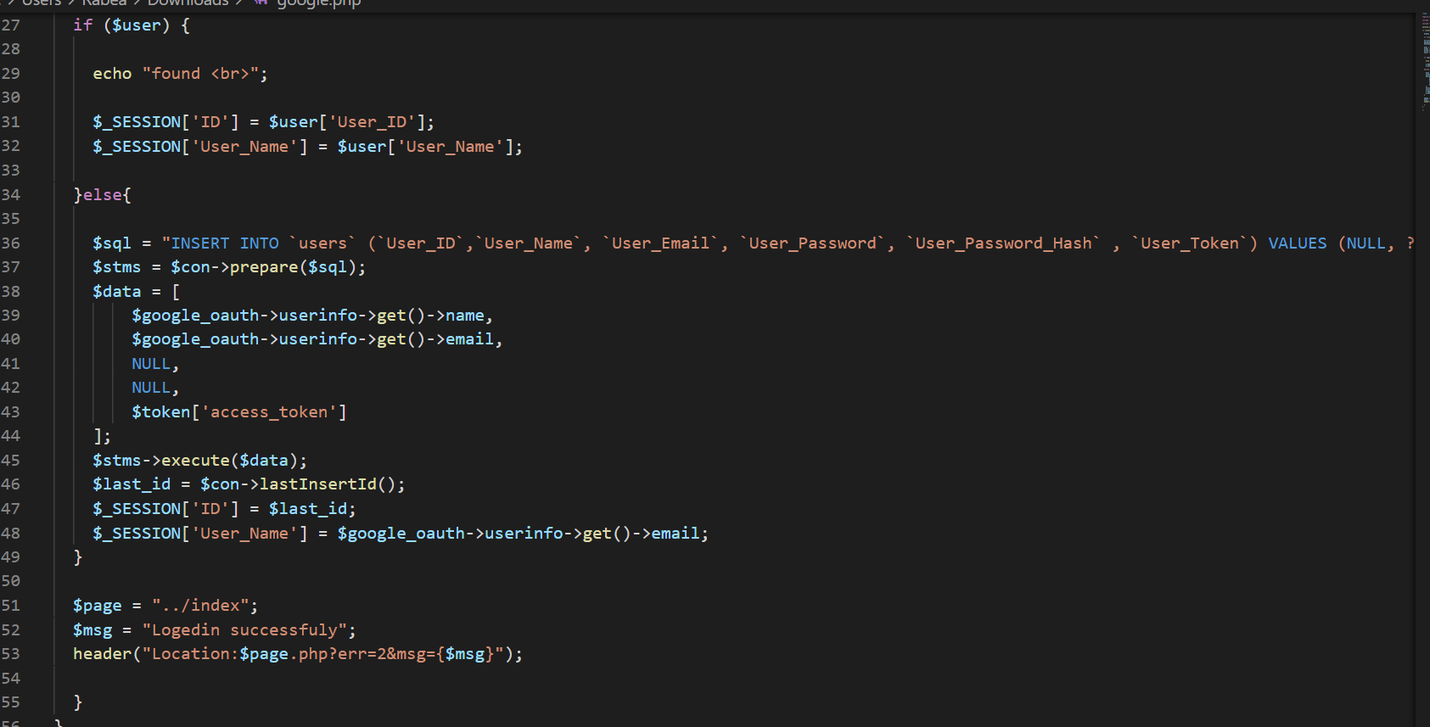

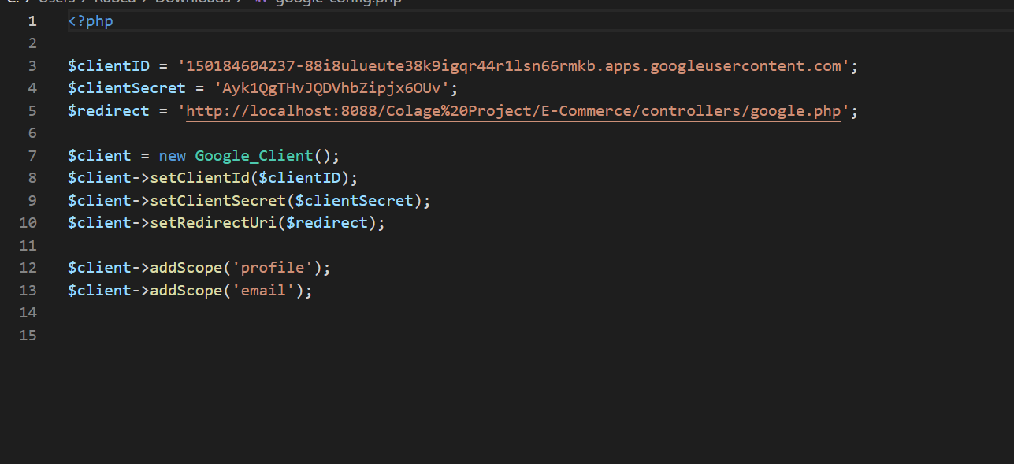

The login process is valid after the data has been successfully registered, and the user is sent to the home page.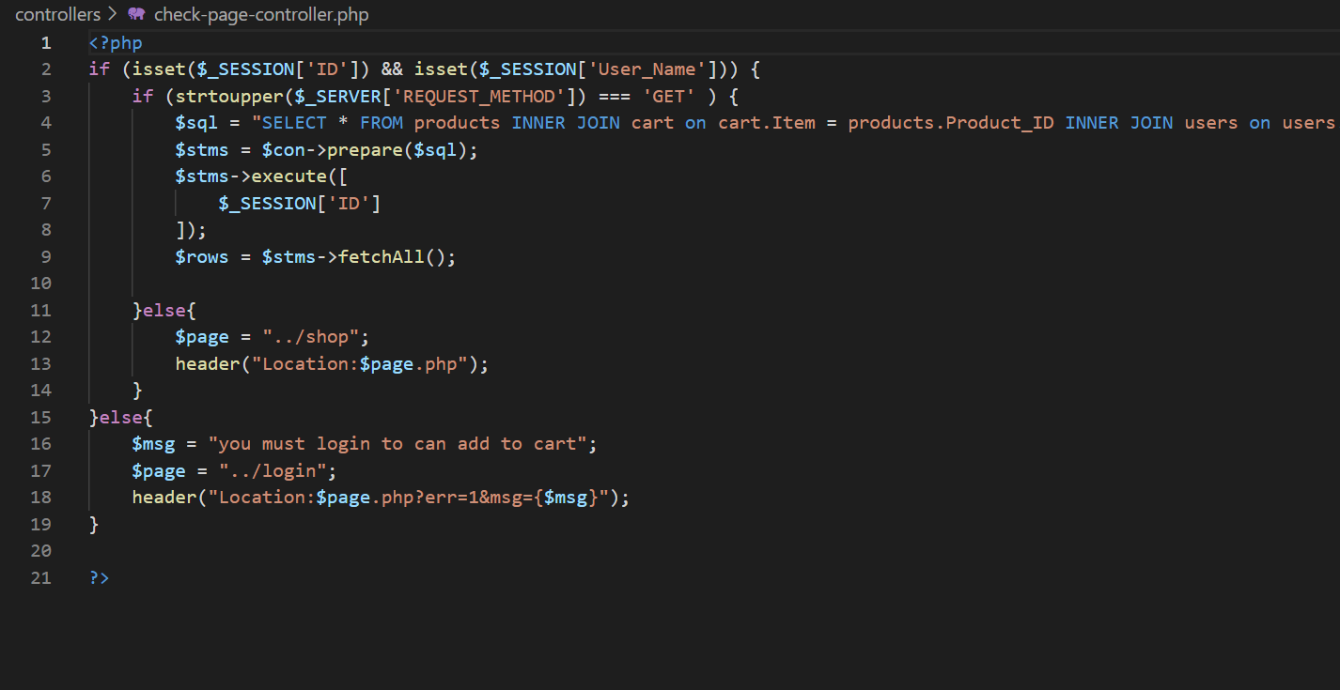

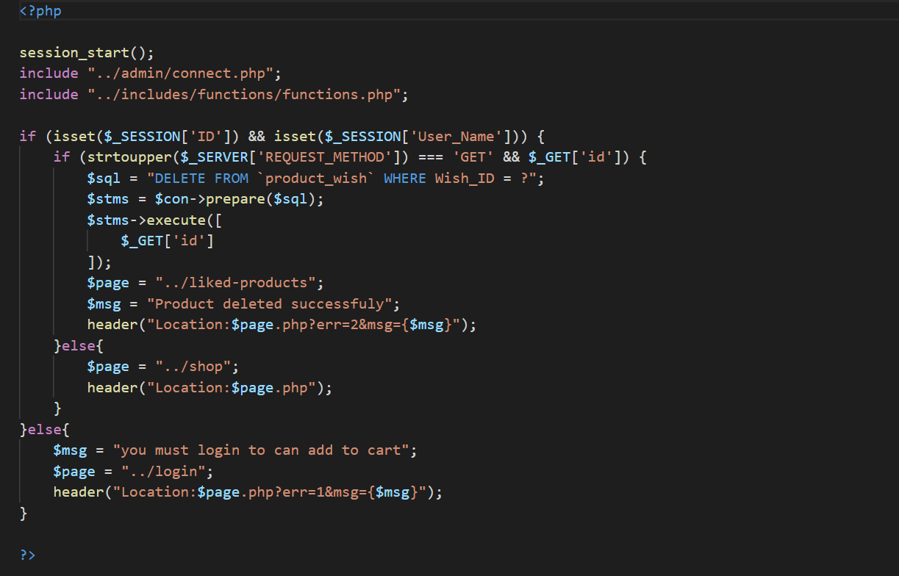the site catches the user's id in a request to delete from the database.

**Case study**

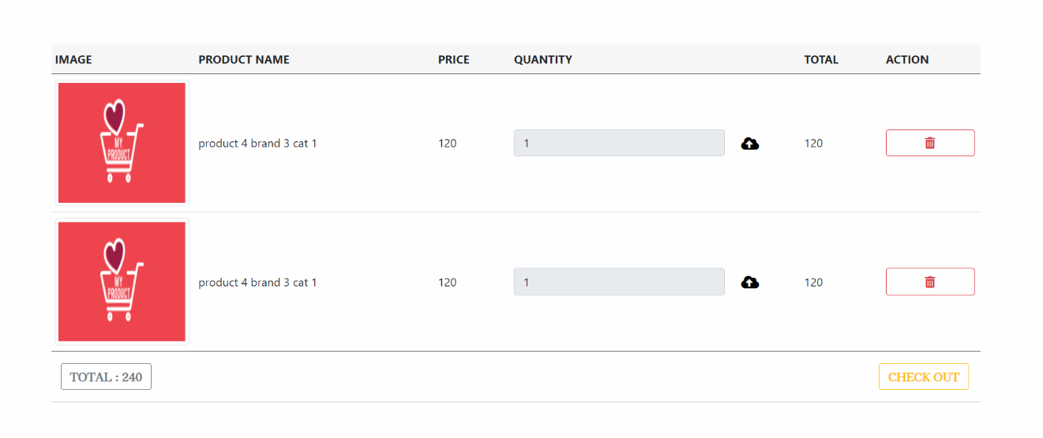

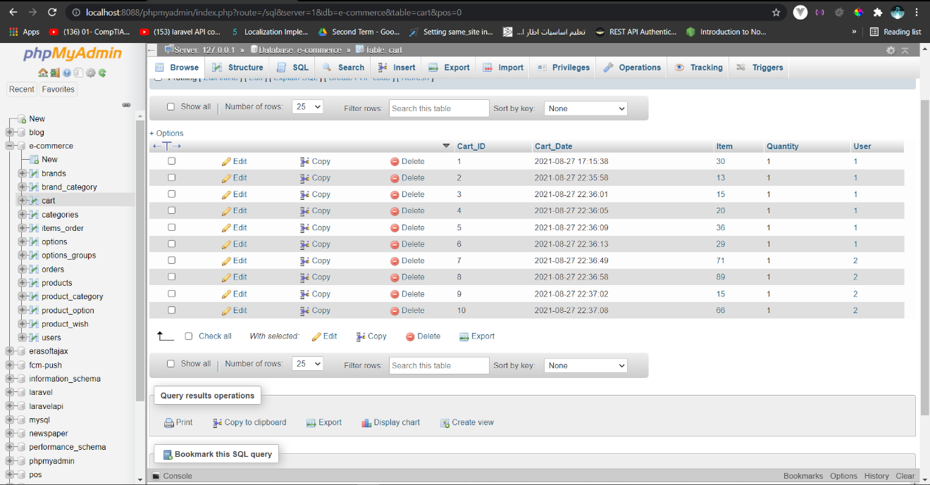

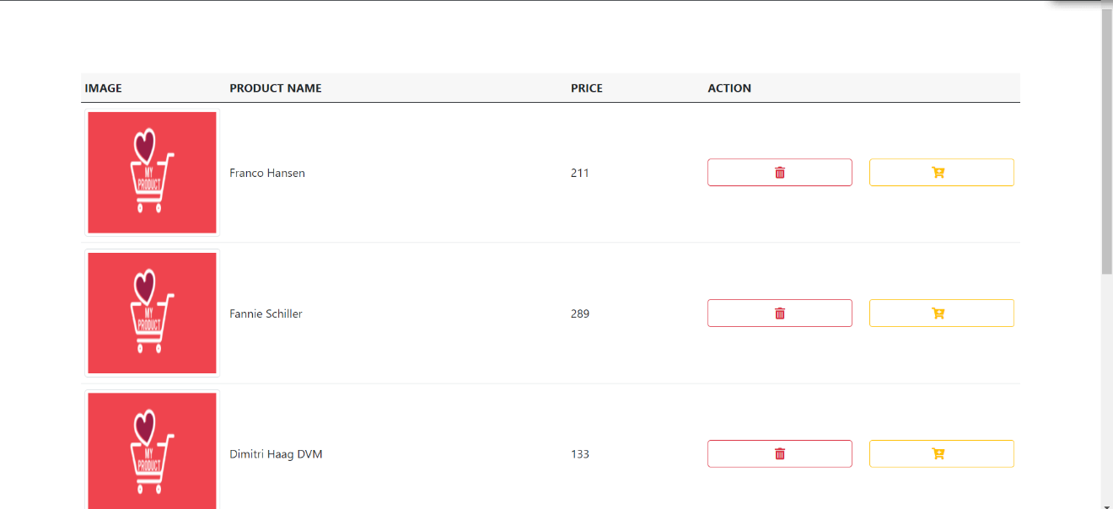

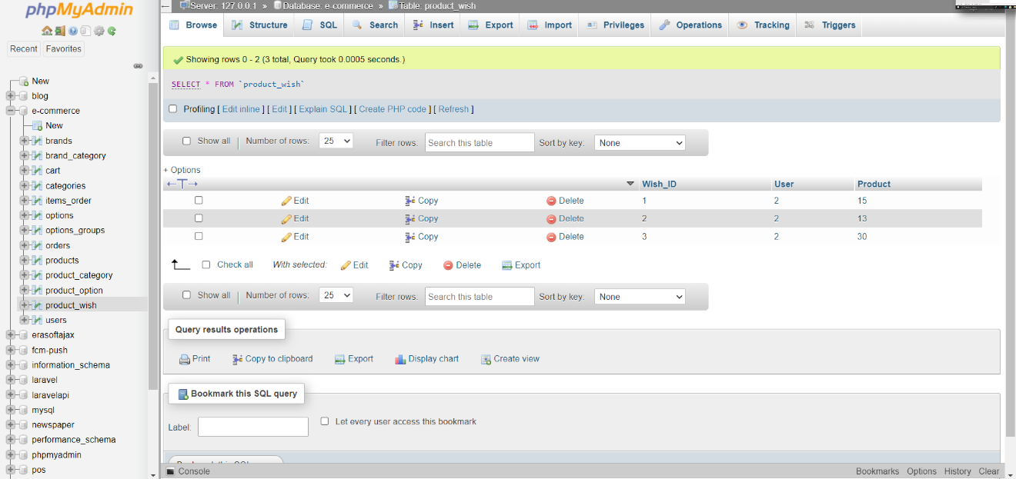

# **Improvements and Extensions**

We now go on to the section where we will discuss the project's weak and strong points, following the previous remarks and introduction...

The user-friendly style, which is simple to use and allows you to make purchases quickly and effortlessly, is one of the best features. You'll be able to look at a lot more options on a single page, which means you'll save time and have better overall stability. It is planned to improve the environment by making it more participative when it comes to the weak points or what to add and alter in the future. To make the search process easier and to ensure that the user has the best possible purchasing experience, a search option will be introduced. In addition, other ambitions for the business include introducing a section for elderly clothing, as well as a feedback panel so other consumers can read and interact with one other's remarks. In the future, we may introduce the "contained advertisements" option, which will allow some agencies and businesses to advertise their products. Customers will be able to place preorders for products that will be available soon, as well as use coupons to save money and take advantage of deals, and an advanced map that uses a GPS system to locate the user's address for a more accurate delivery experience.

# **Conclusion**

Finally, but certainly not least, comes the finale...

We'll restate the headlines we introduced earlier in this section. Starting with the project's main idea, which allows users to shop and purchase clothes online with ease, you'll be able to browse and choose from a variety of products including men's, women's, and children's clothing, after which you'll be able to browse and choose from a variety of products including men's, women's, and children's clothing. The goods you've added to your favorites will appear next, followed by your cart, where you can check out your order. You can also filter the items to guarantee that each buyer finds exactly what he's looking for. Then there's the administrator, who has his or her own area to ensure that everything runs well.